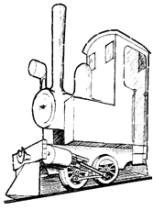
Christchurch Big Model Train Show 2024

Saturday, 12th October & Sunday, 13th October 2024
Public open hours 9:30am – 5pm both days

Trade Stands (including Non – Profit Organisations)
Contact Name: Phone:
Postal Address:
Email:

Web Address

Trading Name:
Number of 1.8m spaces required @ $60 per space (max of 6). …………………….
IMPORTANT: If you are an Incorporated Society then your first space is free!!
An invoice for the cost of attending the show will be sent out in later in the year. Payment is due before the start of the show either to the address below or to the Treasurer at the show during set up on Friday afternoon.

Other Requirements. Do you need to be near (or away from) a particular layout/ trader, need power etc.

**Submitting this document shows your agreement with the Health and safety System of the CMRES in place at the venue (Cowles Stadium) and its environs.

For any queries about the Train Show or the Application Form please call: Bryan 021 056 3323.

Please return by 30th June
No late applications will be received

Email: secretary.cmres@gmail.com
Or post to: CMRES, ^{c}/_{o} 70 Farquhars Rd, Christchurch 8051.

